**Cairn University Alumni Database Project Proposal**

Shay Walker (Project Manager, Software Engineer)

**Introduction**

As Cairn University grows and expands the need for Cairn to keep in contact with its growing number of alumni increases every year. Many alumni are generous donors who contribute to multiple Cairn Scholarships and are successful in their field of study and would love to share their knowledge and be invited to speak at the University. Currently, there is not a consistent and convenient way for Cairn University Alumni to maintain contact with their alma mater or for the University to contact them. For this project, I propose that the database framework that was created through the computer science program at Cairn to be used as a base for the development of a complete Alumni Database. The database would be accessible for the alumni, through password-protected accounts to input and update information about themselves so that the University can maintain meaningful contact and so that the alumni can reconnect with one another.

**Objectives**

* Provide an easy to use interface for Cairn alumni and Cairn employees that acts as a virtual address book
* Establish a means in which Cairn University can reach out to alumni
* Provide Cairn alumni the ability to share their success with other alumni and Cairn employees
* Provide Cairn alumni the opportunity to give back to the University
* Provide Cairn alumni and employees to make meaningful connections with one another
* Provide Cairn alumni with an opportunity to remain in contact and support one another

**Target Audience**

* Cairn Alumni who desire contact with Cairn University and other Cairn alumni

**Value Proposition**

This web interface and database fills the need of having a tool that Cairn University can use to keep up to date and remain in contact with their alumni. This tool would also allow for alumni to reach out and connect with one another without having to hunt through other forms of social media searching for other alumni. The alumni inserting and maintaining the data itself provides for a unique solution in which limited maintenance is needed on the University’s end. No extra staff would need to be hired with the completion of the database and its web interface. Cairn University would gain access to alumni and be able to reach out and connect in order to benefit the growth and expansion of the University.

**Features and Description**

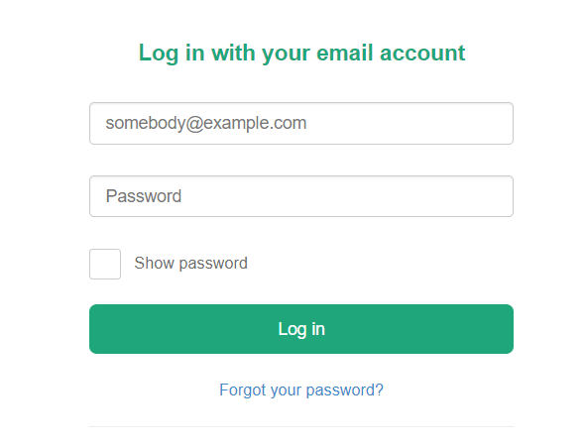Requires users to sign in to access this tool via a web page. The user (alumni) provides the information in the necessary fields, such as the year they graduated. The database will be able to update records, add records, browse through records, delete records, and search for specific records. 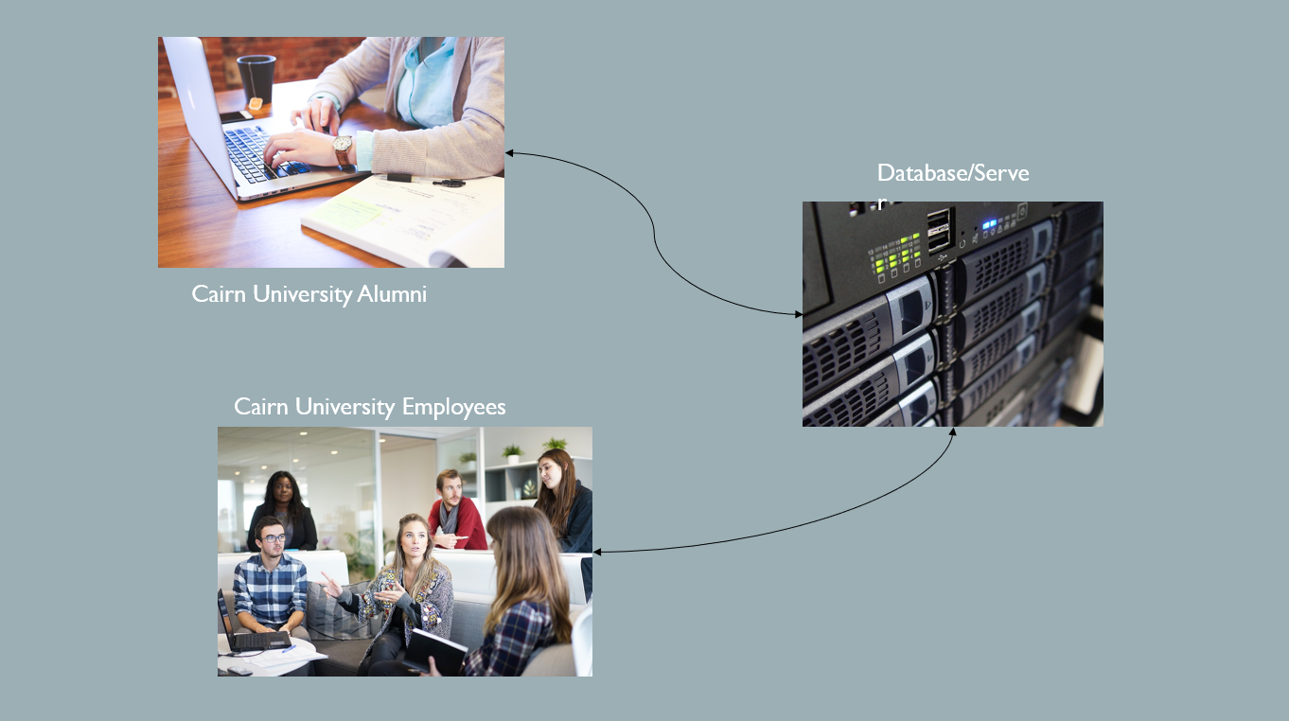

Other features as of the current moment include:

* Registration
* Password Recovery

Please note that all features can be and are subject to change due to the desires and necessities of the users and the creators.

**Project Quote**

The effective rate is $100 per hour. Below are the estimated number of hours needed for each stage of the project.

Planning - 20 Hours

* Brainstorming and Preparation for the Design process

Design - 20 Hours

* Establishing a look and feel along with markups of the actual project

Coding - 40 Hours

* Purposefully using code to write the background for the project using whatever languages necessary

Testing - 20 Hours

* Testing to ensure that the code is functional and performs as expected

Remediation - 30 Hours

* Fixing all code bugs found within the Testing stage

Deployment - 20 Hours

* Implement the product for the first time

Hypercare Support - 20 Hours

* Resolve any issues once the product is deployed

Training - 20 Hours

* User’s Manual composition as well as employee and user training

Documentation - 20 Hours

* All details pertaining to every aspect of the product written out clearly

Ongoing Support - As Needed

* Any future problems or updates that need to be resolved

Due to the fact that aspects may take more time or less time depending on certain circumstances, there is a +/- 20% in the quote price range as given below.

Entire Project:

***210 Hours = $21,000***

***+/- 20% = $16,800 - $25,200***

**Project Timeline**

Key dates include the following.

Planning - January 30, 2019 - February 13, 2019

Design - February 6, 2019 - February 20, 2019

Coding Development - February 20, 2019 - March 27, 2019

Testing & Training - March 27, 2019 - April 10, 2019

Deployment - April 10, 2019 - April 17, 2019

Remediation & Hypercare - April 17, 2019 - May 1, 2019

Documentation - May 1, 2019 - May 8, 2019

Final Project completion on May 8, 2019.

**Signatures**

(Project Manager) ___________________________________ Date ___________

(Software Engineer) __________________________________ Date ___________

(Client/Customer) ___________________________________ _Date ___________